Bryan Barrows

MIC 215

Website 2: Babylon

Website Purpose: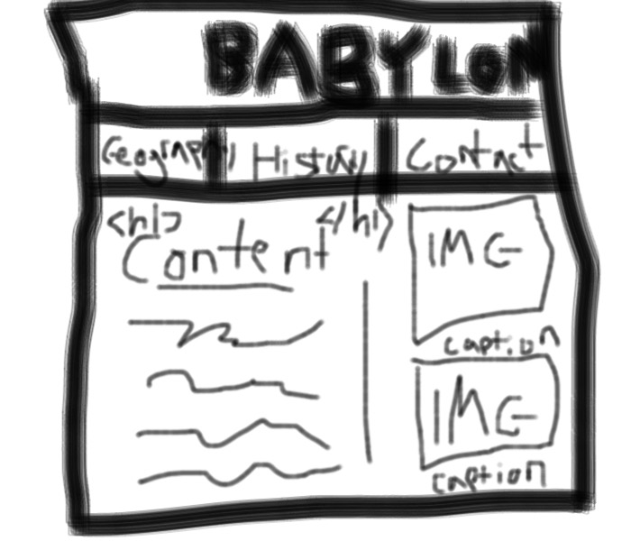

The purpose of my website is to provide a general overview of Babylon, not delving too deep on any subject, but providing a brief primer on it’s history and geography.

Website Audience:

English speaking audience with an interest in history. Some vocabulary may exceed the reading level of children. Audience will mostly connect on a desktop or laptop with a high speed connection. Some users will exclusively use mobile, and a few with use both.

I chose to use

## Thumbnails:

HOME

GEOGRAPHY

HISTORY

CONTACT